Introduction to Loops
Sometimes a programmer wants to execute a group of statements a certain number of times. This can be done using loops. Based on this loops are further classified into following main types;
- for loop
- while loop
The for Loop
for loops can iterate over a sequence of iterable objects in python. Iterating over a sequence is nothing but iterating over strings, lists, tuples, sets and dictionaries.
Example: iterating over a string:
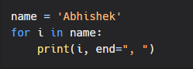
Output:
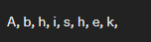
Example: iterating over a list:
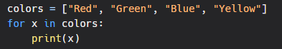
Output:
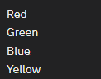
Similarly, we can use loops for lists, sets and dictionaries.
range():
What if we do not want to iterate over a sequence? What if we want to use for loop for a specific number of times?
Here, we can use the range() function.
Example:
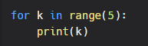
Output:
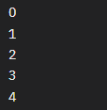
Here, we can see that the loop starts from 0 by default and increments at each iteration.
But we can also loop over a specific range.
Example:
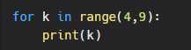
Output:
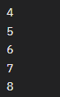
Quick Quiz
Explore about third parameter of range (ie range(x, y, z))

